Teaching and Assessing Science in the 21st Century
A guidebook on using the Next Generation Science Standards as a basis for your education practice.
By Marvin Allen

Table of Contents

Section 1 Introduction
Section 2 How to Read the NGSS
Section 3 Understanding the 3 Dimensions of Learning
Section 4 Unpacking the Standards
Section 5 Assessing the Standards
Section 6 Setting the Anchoring Phenomenon
Section 7 Putting it all together in your lesson plans
Section 8 Templates and worksheets

Section 1 Introduction
America is a powerhouse of technology innovation, scientific development, and medicine. With that being said, many of our nation’s students lag behind the rest of the world in scientific literacy and competency. The Next Generation Science Standards (NGSS) were written to address these concerns. The NGSS was written collaboratively by states, educators, and scientific organizations and released in April 2013. The standards were based on a previous publication called "A Framework for K-12 Science Education," which acted as a vision statement and an extensive list of concepts and skills that form the foundation of a good science education for students of all abilities and career aptitudes.
I was fortunate enough to be studying at the University of Missouri during the development of the standards. I say I was lucky because one of my professors was part of the group of Missouri educators chosen to help write, edit, and pilot the standards. As such, I got a sneak peak of the standards and the process which guided the construction of the standards. Much of the difficulty of interpreting the standards is understanding the thought processes that went into writing the standards. Terms like “disciplinary core idea” make a lot more sense when you have that insider knowledge. My goal in this book is to pass some of that knowledge on to you.
I had another very fortunate opportunity to advance my knowledge of the standards through my participation in grading and writing questions for the Illinois Science Assessment. The Illinois Science Assessment was written around the time that the state’s testing at the high school level transitioned from the ACT to the SAT. The federal government requires that any state and school that receives federal funding tests students in reading, writing, math, AND science. Since the SAT does not have a true science section, this created the necessity for a science standardized test. The ISA was born out of this necessity. In April of 2022 I was chosen to help grade the written response questions that are on the ISA. In October of that same year, I began writing questions for the test as well. Through this process I was trained in how the State of Illinois interprets the standards (which they call the New Illinois Learning Standards).
The Next Generation Science Standards are not like standards in other subjects. A quick look at the common core standards will show you simple and easy to interpret statements such as “Know and apply the Remainder Theorem.” With the NGSS, we are deeply analyzing what we call the three dimensions of learning, how in science we combine a science or engineering practice, with a core idea, and a larger concept to create one performance expectation. Understanding the NGSS is difficult process for both the new teacher and the established veteran. I frequently hear complaints about how the standards are too difficult and, even more worrying, I hear administrators incorrectly directing teachers on their interpretation and use. I have had a string of happy coincidences that have afforded me a lot of training on this topic. This book will help me to pass some of that training on to you, the reader. I’m also going into detail about how to use the learning objectives that I create through the process of unpacking the standards. This includes ideas such as setting an anchoring phenomenon, framing the unit of study with interesting questions, set the pace of my unit of study, and create learning experiences.

Section 2 How to Read the NGSS
Successfully unpacking the NGSS requires you to understand both the performance expectation and the skills and concepts that go into the performance expectation. I will be walking you through the different parts of the standard, what they mean, and how you should interpret them. We won’t be unpacking the standard just yet, first we need understand the standard as written. The picture below is a screen shot of a single standard in high school physics. I will break this down piece by piece to show you how to read each section.
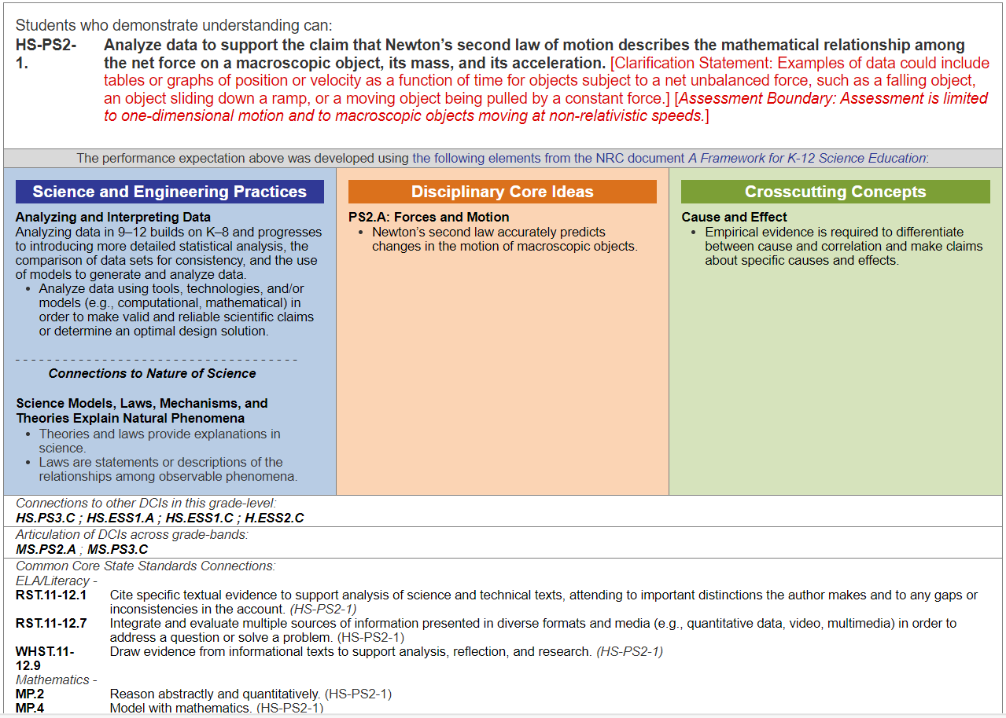
First, let’s look at the least important part of this entire standard which is the performance expectation. I’m approaching it first because it’s what new science teachers tend to focus on. When designing your lessons, the performance expectation can be included as written, but should not be the sole focus of your unit of study. This is contrary to how most administrators will read and interpret the standards. I don’t entirely blame them, because that was the purpose of the performance expectations when the NGSS was initially written. However, standards are open to interpretation and the State of Illinois has made the performance expectation the least important part for you to understand.

Performance Expectation
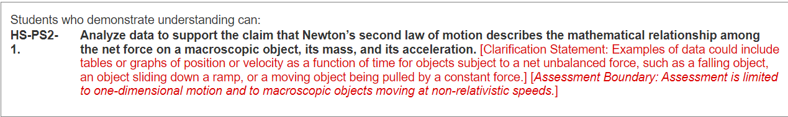
In this performance expectation, students are asked to analyze data to support Newton’s Second Law of Motion. This should be a part of any good unit of study dealing with forces. Unfortunately, many teachers will look at this as the only thing they should teach about forces. This is just one performance expectation of a good unit of study into the matter of forces, not the sole concept that a student of physics should learn. Many performance expectations will include a clarification statement that gives you examples or explanations of the topic. In this case, they give examples of the types of data that would be suitable for this task. We also see on this standard, and most standards, an assessment boundary, which gives us a more specific guide to what should be expected of a high school student. In this case, we are limiting the understanding to one dimensional motion, which gives us a good idea of the level of depth and difficulty the standard is expecting.
Science and Engineering Practices
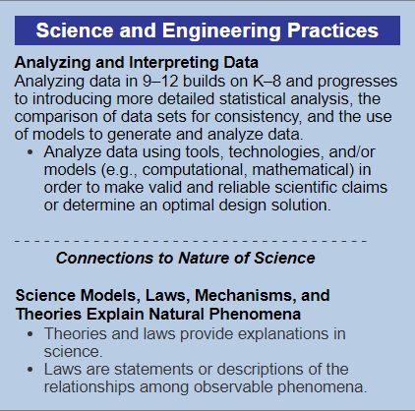
The science and engineering practice (SEP) is a scientific or engineering skills that the standard writers have determined to be the most important in meeting the performance expectation. You cannot meet this particular PE without being able to Analyze and Interpret Data. Pay close attention to the bullet point under the heading, because it gives you the specific skills students will need to meet this standard. Under the dashed line we see a connections section. The connections section gives you a task or concept that they feel is closely related. This is present to allow for you to expand on the students understanding by bringing in a related skill or concept.
Disciplinary Core Idea
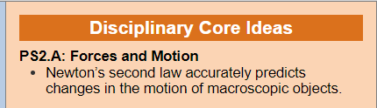
The Disciplinary Core Idea (DCI) is the knowledge component of the standard. This is what we want the kids to know and understand. These are often simple statements but can be more in depth. We don’t see this with my example standard, but often there are multiple DCIs in one standard. As I’ve said before, this does not represent everything a student of physics should learn about Newton’s laws of motion. A good unit of study in physics would include all of Newton’s laws, maybe some facts about Isaac Newton himself, and some practical applications of Newton’s Laws. Students should learn the formula of Newton’s second Law and solve a number of practice problems. The DCI should be seen as one of the big ideas of your unit of study.
Cross Cutting Concepts
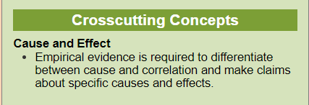
Crosscutting Concepts (CCC) are those ideas which are seen in all different disciplines of science, technology, and engineering. In this example we see the CCC of Cause and Effect. Cause and effect can be seen in this particular standard, that forces cause changes in acceleration of objects. The idea of cause and effect goes well beyond my physics classroom. Teachers down the hall from me are teaching cause and effect in biology and earth science.

Connections
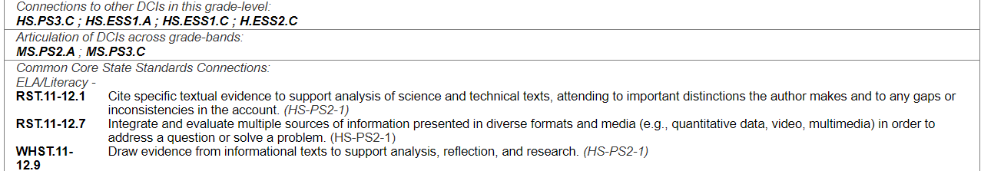
Finally, we have the connections section of the standard. This will include connections to other DCIs. In this standard, there is a connection to HS.PS3.C which is the relationship between energy and forces. This allows you to make those important connections from one unit of study to another. The articulation of DCIs allow you to see the progression of this topic from elementary school and middle school. They will learn about forces in middle school, and you should know what they are expected to learn before you approach the topic in your high school class. If you are an elementary biology teacher, shouldn’t you know what they learned in elementary school? This is a convenient way to see the progression of those topics from one grade band to another. Last is the connection to the Common Core State Standards. The Common Core is like NGSS for Math and English. A multistate effort to come up with a list of everything the students should learn in high school about math and English. These are directly related to the standard you are trying to teach. A student cannot complete my learning standard without being first able to draw evidence from texts and cite evidence from those texts.

Section 3: Understanding the 3 Dimensions of Learning
The NGSS fundamentally changes the way that science learning should occur. Science is a discipline where a wide range of knowledge and skills are applied to answer questions and solve problems. I’m often reminded of this when reading the works of Dr. Neil Shubin. Dr. Shubin is an anatomy professor at the University of Chicago, who’s main clientele are medical school students. What is most interesting about Dr. Shubin is that he is a fish paleontologist. You read that right, his degree and major field of research is in ancient fish. Often times we like to think of scientists as very narrowly focused on one particular field of study or topic. In reality, and especially in modern times, scientists must be skilled in a number of areas of study. My good friend Dr. Kevin Tucker is an assistant professor of chemistry at SIUE where he and his students study the concentrations of pharmaceuticals in fish. The main skill his chemistry students are lacking is dissection. They must dissect the brains from the fish they catch to run their analyses.
When we talk about the 3 dimensions of learning, we are discussing the combination of science and engineering skills, disciplinary core ideas, and cross cutting concepts to solve problems and answer questions. In the example that I wrote about in section 2, the students needed to analyze data (SEP), show evidence for the relationships between force, mass, and acceleration (DCI), and understand the relationship between cause and effect (CCC).
By combining the three dimensions of science—Disciplinary Core Ideas, Science and Engineering Practices, and Crosscutting Concepts— we create a holistic approach to science, where students are drawing from multiple skills, concepts, and understandings to answer a question or to solve a problem.
When writing units of study for a particular topic or group of topics, the 3 dimensions of science are MUCH more important than the performance expectation. In fact, in writing questions for the Illinois Science Assessment, we focused almost exclusively on the SEPs, DCIs, and CCCs of the standard. The specific performance expectation is the least important information you can get from a standard. Often this leads me to ask why they even wrote performance expectations to begin with. I’m convinced that they did so, just to show us how to combine the 3 dimensions into one idea or problem. You should see the performance expectations as a guide to digging into the 3 dimensions.

Section 4 Unpacking the Standards
So, what do we do with these standards? Am I to just go into the classroom and say, “alright kids, today we are going to analyze data to support the claims of Newton’s second law”. If I did so, I imagine my students' eyes would glaze over, and a sense of confusion and bewilderment would set upon my class. Instead, we must unpack the standards, which simply means to make the standards suitable for the consumption of children. In addition, many units of study will involve multiple standards. We must integrate the ideas of the standards together or we risk not teaching the students the interdisciplinary nature of scientific ideas.
Unpacking the standards really starts with arranging the standards into units of study that make sense. The NGSS likes to call this a “storyline” arrangement. By putting similar or related standards together, you can link them by common phenomena. In other words, you are telling a story with the standards. I’m going to use a middle school example to illustrate this concept.
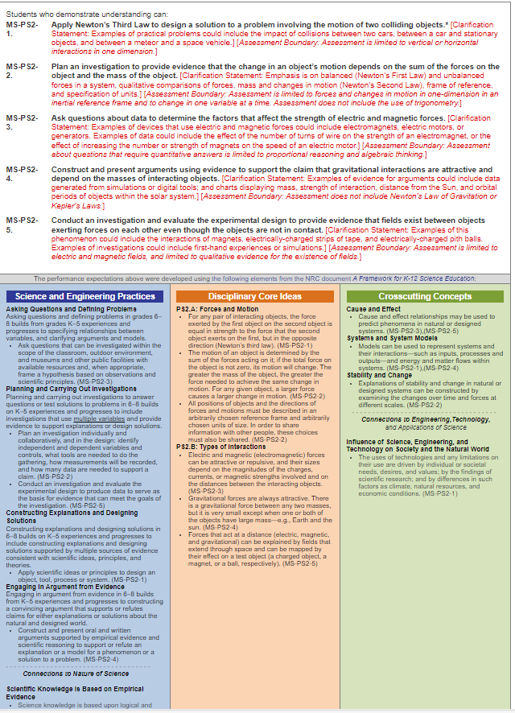
This is the middle school storyline of Forces and Interactions. You can see that these standards all have a similar thread that links them together. This will give you an idea of how to organize your units of study, and it’s what I consider to be the first step to unpacking an NGSS standard.
Next we are going to look at one particular standard in this storyline to continue unpacking the standards.
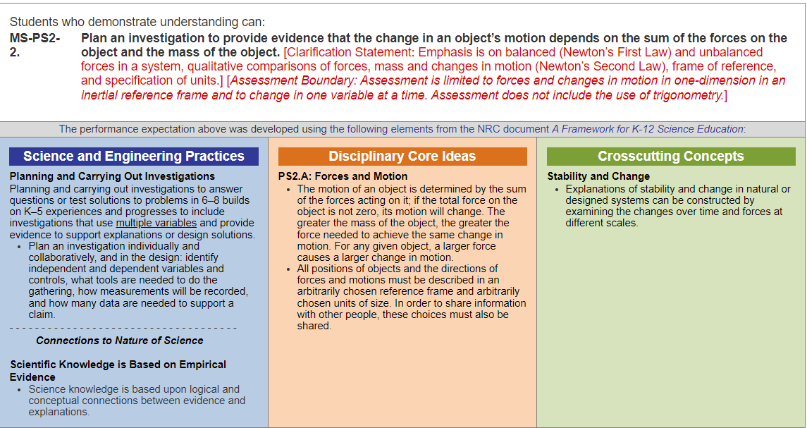
Next, I’m going to start taking all of this information and turning it into actionable steps. Things the students should know or be able to do. For example, a big idea in this standard is the ability to Plan an investigation. So, my first learning objective is:
“Students will be able to plan and conduct a scientific experiment on motion”
You can see that these learning objectives are at a deep level of understanding. The idea behind this is to build multiple learning objectives for one standard. For an example:
“Students will be able to describe the directions of forces and motion using a common convention”
“Students will be able to describe how forces cause changes in motion”
“Students will be able to measure the forces acting on an object”
There are a lot of objectives that you could write from this standard. Objectives are not a list of everything they need to know, but the deeper knowledge and skills that you want your students to have. The important part of this is that you as the professional teacher, or you as a group of teachers in a professional learning community, must come up with your own objectives. Giving you a list of objectives that I have created will not do you any good. You must take in this information, process it, and then give it to the students. Otherwise, the information and objectives aren’t real to you. I could certainly give you a list of objectives, but if you don’t know how they are interconnected, you won’t really be teaching the 3 dimensions of learning. Two different teachers in different schools can come up with differently worded objectives and both still be adequately covering the standard.
The final step in the process is to create learning targets. Each objective can be broken down into smaller chunks of knowledge and skills that can be assessed throughout the unit of study. Let’s take one of my learning objectives from above and turn it into a learning target:
“Students will be able to describe how forces cause changes in motion”
Now lets break that into smaller learning targets. I usually write these as “I can” statements.
I can define force
I can describe changes in motion
I can name the forces acting on an object
I can describe net force
I can calculate net force
This is not meant to be an exhaustive list, but rather an example of the unpacking of the standards, first into storylines, second into learning objectives, and finally into learning targets. I want you to see the relationship between them. The standard calls for a student to conduct and experiment on force and motion. You certainly cannot do that without first describing the relationship between the two. You cannot explain the relationship of force and motion if you don’t have an accurate idea of forces in general.
Now I know what you are thinking, you are thinking that you are going to have to completely rewrite every single assignment, assessment, and lab that you do. In actuality, you are probably already teaching all of these learning targets and learning objectives. When unpacking standards, its important to remember that you don’t necessarily have to rewrite everything you already do. What unpacking the standards allows you to do is to start thinking about small changes you can make to improve science learning in your classroom. It also allows you to start thinking about the topics that are most important and covered in the standards. It doesn’t mean that you cannot teach outside of the standards, but that you should prioritize the meeting of standards by ALL students.

Section 5 Assessing the Standards
Now that we have our standards unpacked and learning objectives and targets written, we now need to make sure that we are assessing those learning targets. Assessment can mean a lot of things. It could be as small as an exit ticket or as large as a project lasting multiple days. The key to assessment is to make sure that you are covering all three dimensions of learning. A test that simply asks students to define force and identify different forces will not be enough to meet the standard. A well written unit of study will include multiple formative assessments and one summative assessment at the end. For my physics units of study, I tend to write two formative assessments and one summative assessment for each unit of study, with the goal if giving one a week over a three week unit of study. I don’t force this if it doesn’t fit for a particular unit but I do follow this pattern as often as possible.
I’m going to explain to you how I write assessment questions, which is based on my work with the Illinois Science Assessment. The process will seem complicated at first but once you get some practice it becomes much easier. The first thing you need to do is make sure that you are assessing all the learning targets that we identified above. Those are your more basic questions on an assessment that can cover just one dimension. In the question below we are assessing just one learning target, not the DCI as a whole.
Which of these best describes a force
a. Push or pull
b. a direction of motion
c. an acceleration
d. a type of energy
When writing two dimensional questions we need to combine an SEP with a DCI or a DCI with a crosscutting concept. Now they are already connected in the performance expectation, but in the Illinois science assessment we mix and match the SEPs and the DCIs of a cluster of standards (usually 2 or 3). “Performing an experiment on forces and motion” is just as valid as “asking clarifying questions on forces and motion”. Be creative with these questions and you can come up with some amazing 2 d assessment questions. Be cautious of DCIs when writing these as a single DCI may have multiple concepts that all need to be assessed. Sometimes it takes more than one question to cover the concepts. When I pair two standards, I will write 14 questions to go with the pair. 12 of those will be multiple choice and 2 will be constructed response. In the question below we are examining the students’ ability to think of experimental design as it relates to force and motion.

Which of the following experiments would allow you to examine the relationship between force and motion.
a. An experiment where you measured how much time it takes to drive a certain distance.
b. An experiment where you measured the forces acting on an object moving across a table.
c. An experiment where you measured both the speed and time of a moving object.
d. An experiment where you measured both the forces on an object and the speed of the object.
Finally, we need to write questions that are 3 dimensional and cover an SEP, a DCI, and a CCC. These can be written as multiple choice, and I usually try to make about ⅓ of my multiple-choice questions 3 dimensional. All my written response questions are 3 dimensional. These take some patience and effort on your part, but as educators it's important that we do so, because our students will take the ISA and will be responsible for answering those types of questions. In the written response question below, we are examining the students’ ability to design an experiment, explain the relationship between force and motion, and their ability to recognize stability and change in the experimental system.
“Design an experiment where you examine the relationship between force and motion. Be sure to include what factors you plan on changing in the experiment and what factors will remain the same in the experiment. “

Sometimes the hardest part of writing NGSS questions is envisioning how they would start or how you would structure them. Below I’m going to lay out some starters and ideas to help you get started writing 2d and 3d assessment items
Science and Engineering Practices
Asking questions and defining problems – your questions can ask students to lay out the problem of a design or model. You could also give a list of potential questions and ask students to pick the one that is scientific.
Developing and using models – This one is usually going to be using a model rather than developing which is more appropriate for a performance task. On a test, I would give the students a model and ask them questions about the model.
Planning and Carrying Out Investigations – Focus on planning for a summative assessment, such as “which type of graph would you use” or “what are the independent and dependent variables”
Analyzing and Interpreting Data – Give them a graph and have them answer questions about it.
Using Mathematics and Computational Thinking – Give them a situation that will require using an equation to solve.
Constructing Explanations and Designing Solutions – Have students explain a situation using Claim, evidence, reasoning.
Engaging In Argument from Evidence – Another place where CER shines!
Obtaining, Evaluating, and Communicating Information – Focus on communication for a paper assessment, think ACT style question where they need to use persuasive writing skills and evidence.
Disciplinary Core Idea
This one is easy so I won’t say much. Mainly, don’t focus on memorization. A great example would be giving the students a graph of Force vs. Mass and have them come up with the acceleration using Newton’s second law. Rather than simply memorizing the equation, they actually have to use it to solve a problem. Less memorization and more doing!
Crosscutting Concepts
Patterns – Have students look at data and find a pattern in the data. Doesn’t have to be numbers, could be qualitative data. Pictures of homologous structures along with the question of construct an explanation for the similarity of structures using claim, evidence, reasoning.
Cause and effect – have students look for a mechanism of action rather than an input or an output. Baking soda and vinegar being an endothermic reaction would be a good one. Why does the reaction get cold, not just memorizing that it is endothermic.
Scale, Proportion, and Quantity – How does time, energy, size affect the situation? How would velocity change if there was more kinetic energy? How long does a reaction take with or without an enzyme?
Systems and Models – Have students interpret a model for boundaries. Momentum is only conserved if the system is both closed and isolated. Does a certain situation apply?
Energy and Matter – Have students track the flow of energy in a situation, or show that a situation follows law of conservation of energy.
Structure and Function – How does the semiconservative nature of DNA replication aid in keeping the integrity of the genetic code?
Stability and Change – What is needed for a system to reach equilibrium, or what conditions will affect rates of change?

Section 6: Setting the Anchoring Phenomenon
We have unpacked the standards and we have written a few assessment items. Now it’s time to start actually teaching the NGSS in our classrooms. Each Unit of study I teach starts with an anchoring phenomenon. Sometimes this process is called storylining, but storylining is a little more intensive than what I do in my classroom so I choose not to use that particular language to describe my process. To understand how I start a unit of study, you need to understand how NGSS has changed science education.
The largest shift to science education that comes with the NGSS is the decrease in importance of science facts and an increase in the importance of science skills, practices, and the concepts that tie the science strands together. These skills, practices, and crosscutting concepts cannot be learned in a vacuum. They need to be used for what they really are, tools for understanding. The best way to teach graphing is to give the students the opportunity to graph, make mistakes, and build understanding. To do this, you need to anchor each of your units in some sort of phenomena or opportunity for problem solving. These phenomena can be real life events, or they can be points of imagination. The whole point of the anchoring phenomenon is to give the students some sort of goal or problem to solve through the course of the unit of study.
So what makes a good anchoring phenomenon or problem? Well first, it has to be something that is complex. In fact, the more complex the better. We don’t want kids to be able to solve the anchoring phenomenon day 1. Second, it has to be a problem or issue that works with the learning targets you are wanting to teach. This is why I advocate writing your anchoring phenomenon later in the process of building a unit of study. You should know what skills and core ideas you want to teach before writing your anchoring phenomenon.
Presenting the anchor is maybe the hardest part for teachers to comprehend. How are you going to present the problem to the students in a way that is meaningful? I prefer storytelling in my teaching practice, but that might not be suitable for you. A lot of teachers find interesting videos to introduce the anchor. What’s important is that you are not giving the students any specific facts or teaching them any skills. You are presenting a problem and having students come up with their initial thoughts.
Following up on the anchor is as important as choosing the anchor. If you just show students a video and then move into lecture, you are going to lose any interest in the phenomenon that you presented. My preferred follow up method is through questioning. I will ask important, difficult to answer, and often provocative questions that I have the students discuss in a think, pair, share sort of set up. You may have students work in groups to come up with a specific solution based on their previous understandings. If you teaching modeling, you might have students build an initial model of the phenomenon. There are a lot of options for how you follow up on the anchor presentation, but they all have in common that students are collaborating on the problem.

Section 7: Putting it all together in your lesson plans
Well it seems like we’ve reinvented the wheel a little bit with all of our hard work so far. Now it’s time to putting everything together into units of study and/or individual lessons. You probably already have a lot of lessons already developed, maybe some lectures and labs that you enjoy doing. Those do NOT have to be replaced. With just little changes here and there, most of your lesson materials are still valid and will likely help you reach your learning objectives. NGSS has changed our focus, how we are going to present materials, but the science hasn’t changed and likely the labs haven’t changed. We are just being more intentional with laying out what specific skills and ideas we are teaching, why we are teaching them, and how we are going to assess them.
I tend to have a very unique planning methodology that doesn’t really track with anything that you can purchase or borrow from a published resource. I have found over the years that my lesson plans really are written in a way that allows me to see the big picture and cohesiveness of the lessons I’m trying to teach. My unit plans are going to include the NGSS standard I’m going to cover in the unit (broken down into the 3D’s of learning), my anchoring phenomenon, anchoring questions (which I call framing questions in class), common misconceptions that students have had throughout my years of teaching, my leaning objectives, and a list of the lessons I’m going to teach and the order in which I’m going to go through them. I have an example below of the first unit of study I cover in my on-track physics class.

Unit 1 – Uniform Motion
11 Days
Big Ideas
Uniform motion means that an object travels equal distance in equal time intervals.
Speed and velocity have different meanings.
Motion can be described in different ways: with words, graphs, diagrams, and mathematical models.
Common Misconceptions
Students often have an undifferentiated idea of motion, so they struggle with specific measurements of motion such as position, velocity, and acceleration.
Students often believe that any two objects that occupy the same position at the same time will necessarily have the same speed.
Students often believe that a leading object must be moving faster than a following object.
Students struggle to “see” velocity vs. time graphs, and will often mistake them for position vs. time graphs.
Students often mistake acceleration for velocity, for example many believe that zero velocity MUST mean zero acceleration.
Students have difficulty in understanding the purpose of graphing, and often get confused by the relationships we derive from the slope of a graph.
Students often think that acceleration is speeding up and deceleration is slowing down.
Students often think that positive acceleration is always speeding up and negative acceleration always means slowing down.
Students often interpret slope and area under a curve literally rather than thinking about them in reference to the scales and units on the axes.
Students struggle with predicting the shape of graphs based on real life motion.
3 dimensions of learning
HS-PS2-1. Analyze data to support the claim that Newton’s second law of motion describes the mathematical relationship among the net force on a macroscopic object, its mass, and its acceleration. (not directly covered until forces, but instead gives a base understanding of motion)
Science and Engineering Practices: Plan an investigation or test a design individually and collaboratively to produce data to serve as the basis for evidence as part of building and revising models, supporting explanations for phenomena, or testing solutions to problems. Consider possible confounding variables or effects and evaluate the investigation’s design to ensure variables are controlled.
Develop and/or use multiple types of models to provide mechanistic accounts and/or predict phenomena, and move flexibly between model types based on merits and limitations.
Analyze data using tools, technologies, and/or models (e.g., computational, mathematical) in order to make valid and reliable scientific claims or determine an optimal design solution.
Apply concepts of statistics and probability (including determining function fits to data, slope, intercept, and correlation coefficient for linear fits) to scientific and engineering questions and problems, using digital tools when feasible.
Use mathematical, computational, and/or algorithmic representations of phenomena or design solutions to describe and/or support claims and/or explanations.
Disciplinary Core Ideas: This unit does not address a DCI directly but lays the groundwork for understanding of Newton’s laws of Motion.
Cross Cutting Concepts: Empirical evidence is required to differentiate between cause and correlation and make claims about specific causes and effects.
Models (e.g., physical, mathematical, computer models) can be used to simulate systems and interactions—including energy, matter, and information flows—within and between systems at different scales.
Change and rates of change can be quantified and modeled over very short or very long periods of time.
Much of science deals with constructing explanations of how things change and how they remain stable.
Learning Objectives with Essential Skills (SWBAT)
- Convert complex units from one form to another
  - Recognize SI and non SI units
  - Use conversion factors to make simple conversions
  - Use dimensional analysis to make complex conversions
  - Recognized derived units and named units
- Analyze data to find position, time, and velocity of a uniformly moving object
  - Distinguish between position, change in position, and distance
  - Distinguish between instantaneous time and time interval
  - Describe the starting position, final position, change in position, and direction of motion
  - Make a position vs time and velocity vs time graph
  - Determine velocity from slope
  - Analyze and compare motion of two objects
- Design and conduct an experiment to study a uniformly moving object
  - Make observations
  - Define variables
  - Make a hypothesis
  - List the steps of a procedure
  - Collect data and input into a table
  - Graph and analyze results
  - Draw conclusions from the data
- Mathematically and graphically determine the displacement, average speed, and velocity of a uniformly moving object.
  - Construct a position vs time graph
  - Construct a velocity vs time graph
  - Compare graphs with differing slopes
  - Use math to calculate speed, displacement, and time interval
- Use multiple representations to describe a uniformly moving object
  - Verbally describe motion
  - Draw a motion diagram
  - Construct motion graphs
  - Mathematically describe motion
  - Recognize similar motion in multiple representations
Opening Phenomenon
We will show students a basic series of motions by walking through the front of the room. Then we will ask them to describe the motion as accurately as possible. Then we show them a description of the motion using words, graphs, diagrams, and mathematical models.

Order of lessons/activities
Chapter Opener w/ Bag of Cars Lab 1.1
Lecture 1.1: Position, Distance, and Displacement
Graphing using logger pro Lab 1.2
Lecture 1.2: Unit Conversions, derived units, graphing, and sig figs
Battery Car Lab 1.3
Lecture 1.3: Speed and Velocity
Lecture 1.4: Motion diagrams
Graph Matching Lab 1.4
Uniform Motion Card Sort
Review Activity
Assessment

Demonstrations
Various moving toys and cars

Lesson Plans
Day 1: Chapter Opener/ Car Lab
Objective: To introduce the ideas of uniform motion, set the anchoring phenomenon, and give a reference frame via questioning and an inquiry lab.
Big Ideas: Present the big ideas for the unit
Anchoring Phenomenon: You will need to read over the descriptions of motion and act this out in front of the students. Ask them to describe your motion as accurately as possible. Once they have had some time, pick a few students to share. Finally, show the scientific descriptions of motion. Be sure to tell them that you aren’t trying to prove how smart you are, but rather you are giving them a glimpse of what they themselves will be able to do by the end of the unit.
Framing Questions: Deliver the framing questions, ask them to give their thoughts, but remember to NOT give them an answer. They should be hungry for an answer and attempt via the lessons to gain the information on their own.
Car Inquiry Lab: Have the students get into their lab groups and follow the directions to the lab. This is open-ended so you shouldn’t be helping them too much. Make sure you leave time to debrief the lab.
Evaluation: informal discussion of the lab, completion grade only.
Day 2: Lecture 1.1
Objectives: 2a,b,c,f; 4d; 5d
Lecture notes can be found in virtual form in the powerpoint
Lesson: This lecture is on position, displacement, and distance. Before we can start to build an understanding of change in systems, we need to be able to accurately identify where something is at in the system. Relate position to things they already know, the location of their classroom, their home address, latitude and longitude, zipcode, etc.
Explain that position in physics is all about imagining the world as if it were on a coordinate plane. Everything in the world can be seen as if it had an x axis, y axis, and z axis component. Its best at this point to tell the students that in regular physics, we ignore z to make our lives easier. Then we need a reference point. In physics, on our coordinate plane, the reference point is the origin. We can place the origin wherever we like, but we must remain consistent. I often place the origin as the point where I stand to lecture to the class (front of the room, off to the right of my demonstration desk).
For distance and displacement, we will begin to understand the difference between vector and scalar quantities. Vectors have a magnitude (amount) and a direction. Scalars have just a magnitude.
This lecture ends with practice in solving distance and displacement problems. A few are listed on the PowerPoint for practice
Evaluation: skills check 1.1
Day 3: Graphing Using Logger Pro Lab 1.2
Objectives: 3f,g; 4a; 5c
Purpose: This lab allows you to teach a few concepts including: good graphing etiquette, how to analyze graphs, deriving equations from graphs, and prepares them to conduct their own experimentation.
Alternatives: This could similarly be done with vernier, pasco, or other digital data collection devices. You could also use spark timers to collect the data and analyze results.
Evaluation: successful completion of the lab, not graded for specific results.
Day 4: Lecture 1.2
Lecture notes can be found in virtual form in the powerpoint
Objectives: 1a,b,c,d; 4a,b,c
Lesson: Lecture 1.2 is about positions graphs, and what kind of things we can learn from position graphs. We will compare multiple graphs and get some qualitative understandings from the shape of the graph. Then we will look at our derived formula from the previous lab and begin to work some math problems. We will learn about SI units of measure and how to convert units using dimensional analysis.
Evaluation: skills check 1.2
Day 5: Battery Car Lab
Objectives: 3all; 4a; 5c
Purpose: Create and analyze a position vs. time graph. Students will use this lab to practice scientific experimentation, creating and analyzing position vs. time graphs, and deriving the relevance and units of the slope (velocity).
Evaluation: Lab graded for accuracy.
Day 6: Lecture 1.3
Lecture notes can be found in virtual form in the powerpoint
Objectives: 2d,e; 4c,d; 5e
Lesson: Speed and Velocity. This lesson will elaborate on the lab that we just completed with the battery cars. The students should have already derived velocity from the lab. Those that didn’t quite get it will be reinforced in their understanding with this lecture.
We will delve into instantaneous speed, average speed, and velocity definitions. Students will be introduced to the velocity and speed equations.
Evaluation: Skills check 1.3
Day 7: Lecture 1.4
Lecture notes can be found in virtual form in the powerpoint
Objectives: 2f; 5a,b
Lesson: This lesson will be on verbal descriptions of motion and creating motion diagrams. Motion diagrams allow us to quickly analyze a situation without numbers. This gives us a useful model on which we can build. Diagraming and modeling situations will be a concept that continues throughout the course, so it is important that we begin practicing these skills.
Evaluation: Skills check 1.4
Day 8: Graph matching lab
Objectives: 2 all; 4a,b,c; 5c
Purpose: Students will be using the iOlabs, along with the knowledge they have learned from the previous learning activities, to make predictions of motion. This will examine the ability of the students to “see” or predict what the different representations of motion will look like for real life examples of motion and then recreate that motion using the iOlab.
Alternatives: this can be done with vernier motion detectors as well
Evaluation: Lab graded for accuracy
Day 9: Card Sort
Objectives: 2f: 5 all
Lesson: This is a card sort and whiteboarding activity, where students will be given multiple representations of 4 different scenarios. These representations will include a verbal description, a position vs time graph, a velocity vs time graph, and a motion diagram. Each group will be given a whiteboard and all the representations in a random order. There job is to organize the representations by scenario such that they all describe the same type of motion.
Whiteboarding can be done in speed date form or gallery walk form.
Evaluation: informal, ensuring groups came to the same correct conclusion
Day 10: Review Activity
Objective: To review all the information for the test
Lesson: Practice problems could be done as whiteboarding, online quiz game, or working together on problems. Use multiple different strategies throughout the year so it doesn’t get dry
Day 11: Assessment
Unit 1 Exam

Section 8: Templates and Worksheets
Below I’m going to include a few reproducible that can help you to write very good learning targets, assessments, and unit plans. Feel free to make copies of these, cut and paste them into new word documents, or use them however you would like to use them.

Unpacking the Standards Worksheet

Step 1: List the Performance Expectation you want to cover

Step 2: List the SEP, DCI, and CCC that correlate to your PE

SEP: | DCI: | CCC:

Step 3: List the concepts, ideas, practices, etc. that a student needs to know in order to be successful in meeting the standard above. This list can be as long or as short as you need. Next to each concept, write an “I can” statement. These are your learning objectives! (or learning targets, or essential understandings, whatever you want to call them!)

Concept, Idea, or Practice | I can (explain, differentiate, understand, etc.)

Step 4: List all the skills that a student needs in order to be successful in meeting each of the learning objectives you came up with from above. There is no minimum or maximum!

I can statement from above | Skills students need to meet this objective  1.  2.  3.

Step 5: Start to put together your “I can” statements from steps 3 and 4 above, with the learning activities you ALREADY DO in class. Fill in the gaps with new and “new to you” activities and discard the activities that don’t align to a standard.

Lesson or day 1 | I can ……..
Lesson or day 2
Lesson or day 3
Lesson or day 4
Lesson or day 5

Unit Plan Template
Chapter number and name:
# days

Unit Big Ideas

Objectives (SWBAT)

(get these from the worksheet above)

Illinois Learning Standards

NGSS Performance Expectation:

3-D Learning

Science and Engineering Practices:

Disciplinary Core Ideas:

Crosscutting Concepts:

Learning Activities

Assessment

Learning Plan

Day 1 | Objectives:  Learning Activities:  Assignment:  Assessment:
Day 2 | Objectives:  Learning Activities:  Assignment:  Assessment:
Day 3 | Objectives:  Learning Activities:  Assignment:  Assessment:
Day 4 | Objectives:  Learning Activities:  Assignment:  Assessment:
Day 5 | Objectives:  Learning Activities:  Assignment:  Assessment:
Day 6 | Objectives:  Learning Activities:  Assignment:  Assessment:

(extend this as needed)

Works Cited
NGSS Lead States. 2013. Next Generation Science Standards: For States, By States. Washington, DC: The National Academies Press.

